# BATCH NUMBER: B9-3A5E

***PROCEDURE FOR IBM WATSON IOT DEVICE CREATION:***

* ***To connect IOT devices with IBM platform***

Step 1: Go to IBM cloud and click catalog. Now select services and

then select Internet Of Things and Internet of Things Platform.

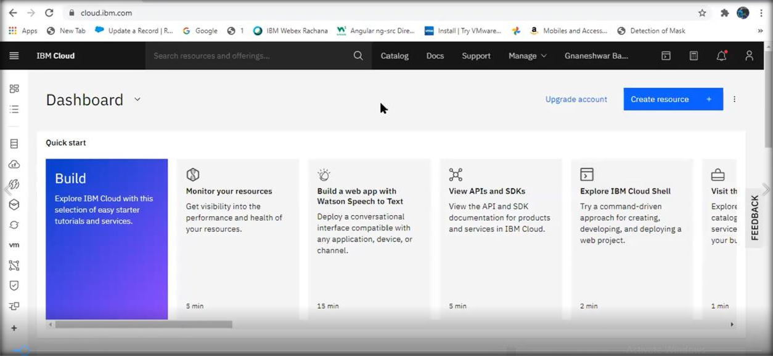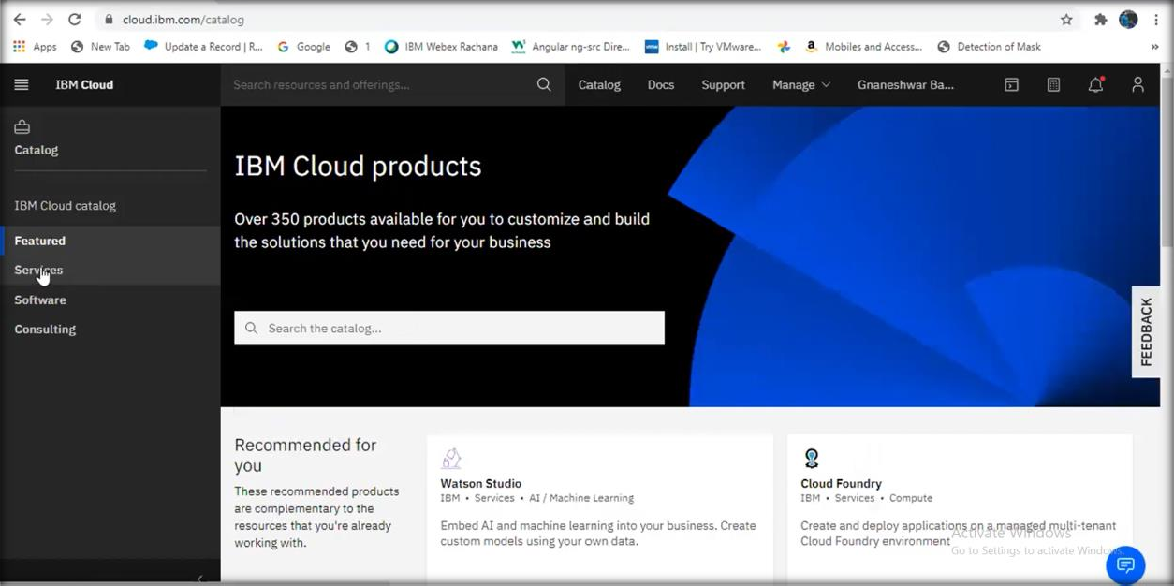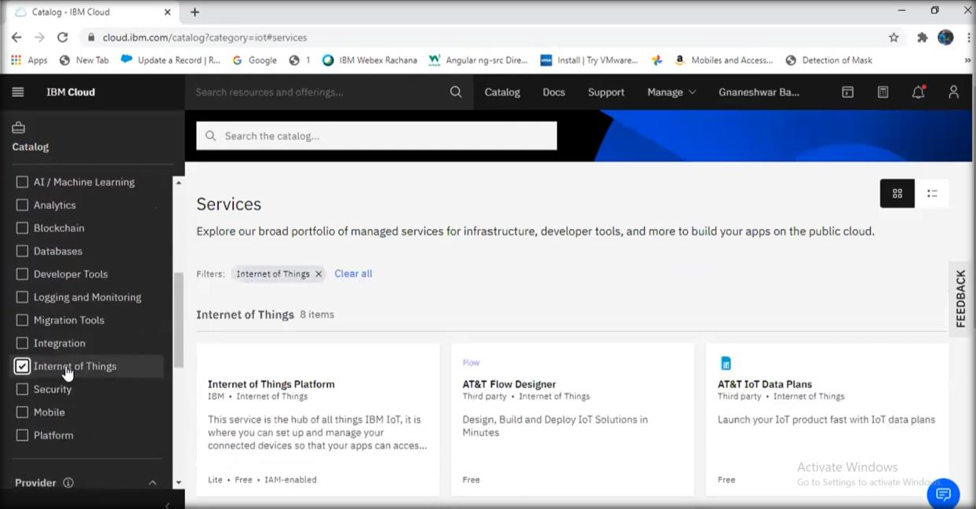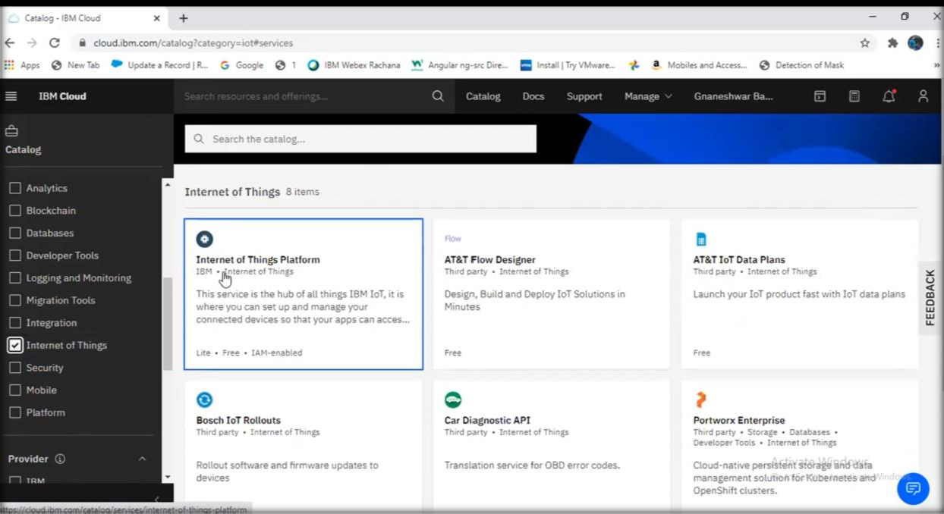

Step 2: Now you will be redirected to a new page. Here, select the

region, pricing plan and service name and click create.

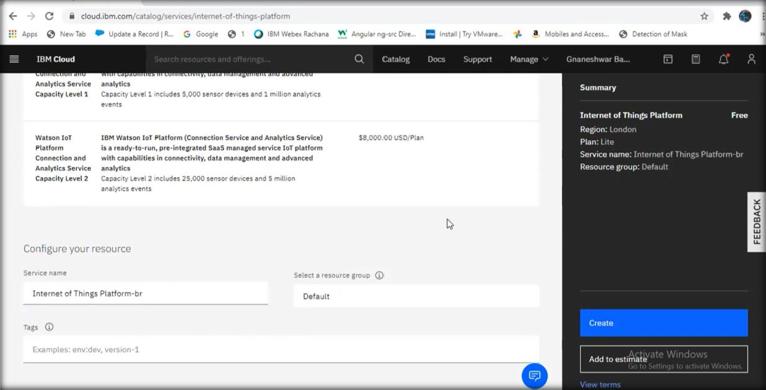

Step 3: As a next step you’ll be redirected to the page ‘Internet Of

Things Platform-br’.Here click launch.

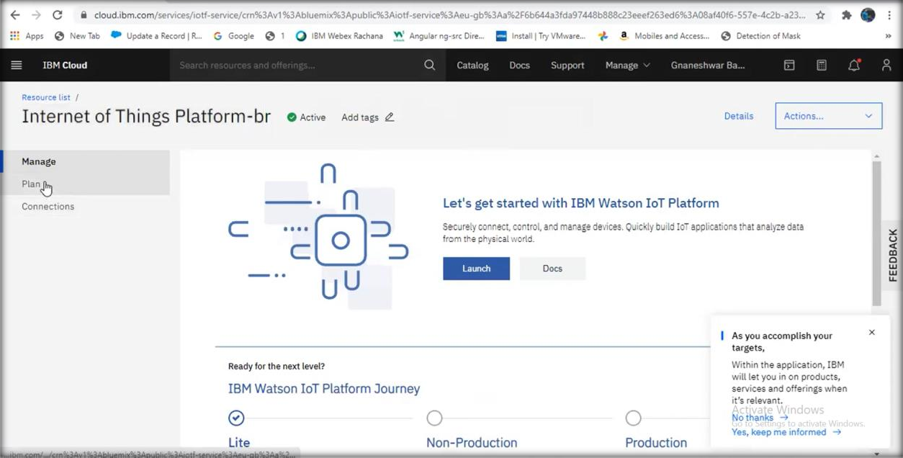

Step 4: IBM Watson IOT Platform will be launched. Click on sign in and

login using your IBM registered credentials.

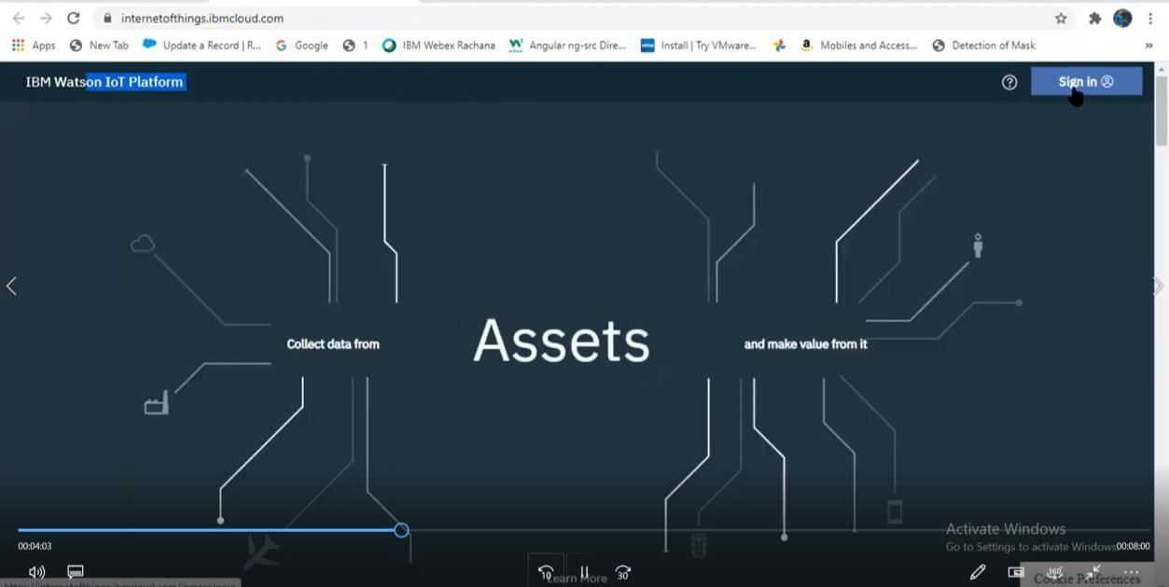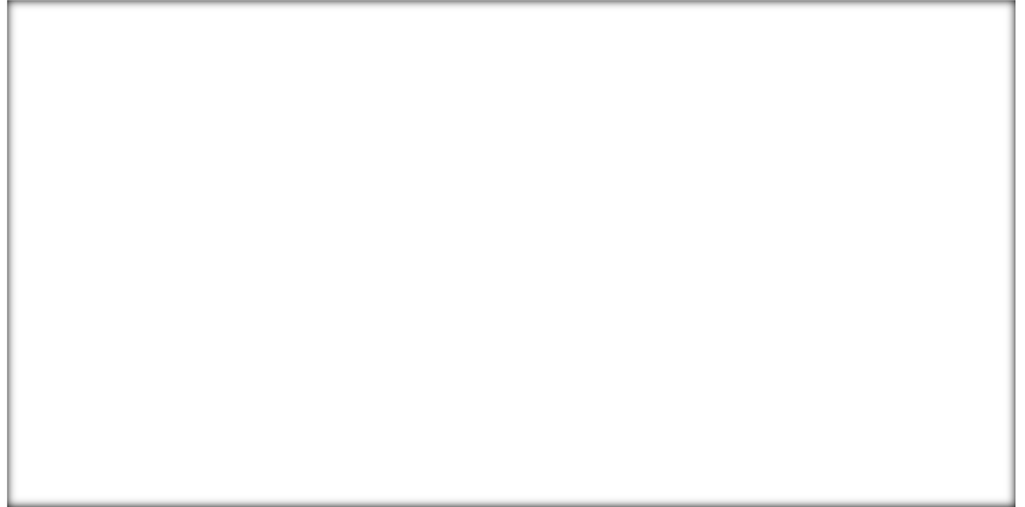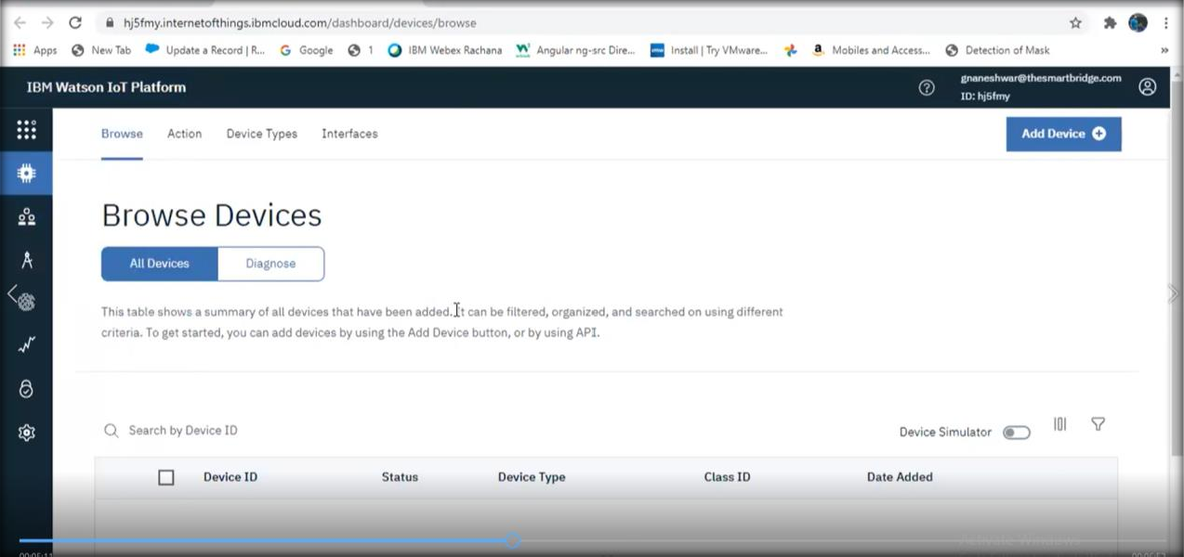

Step 5: Under devices, click create device. Enter the device details and click finish.

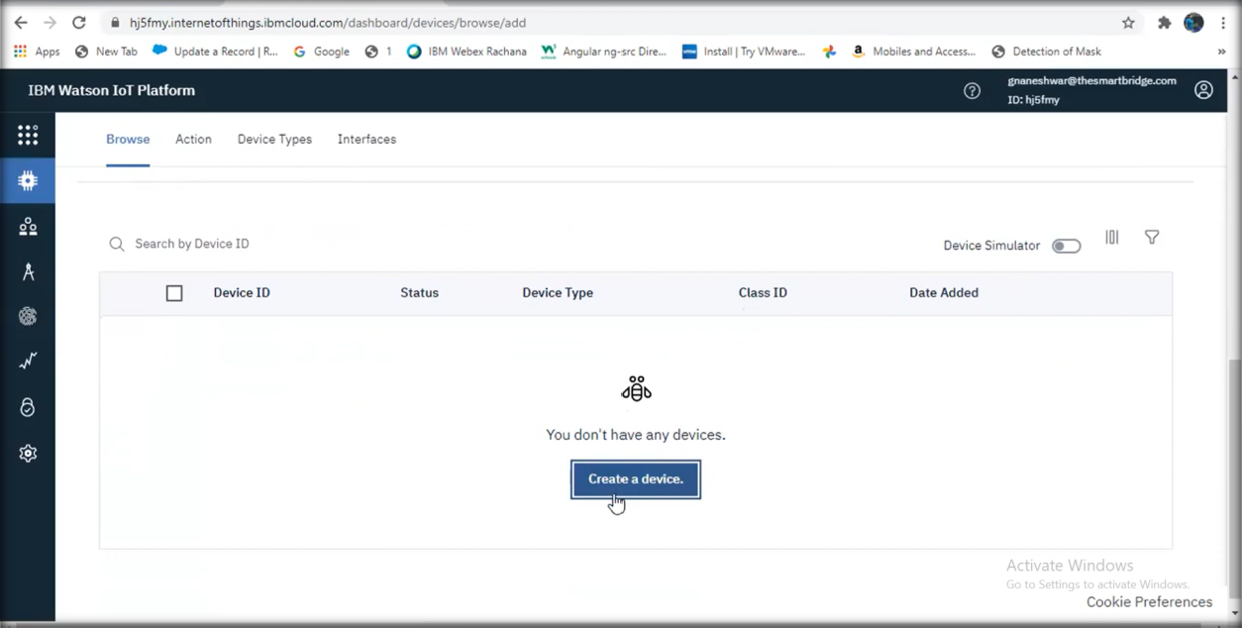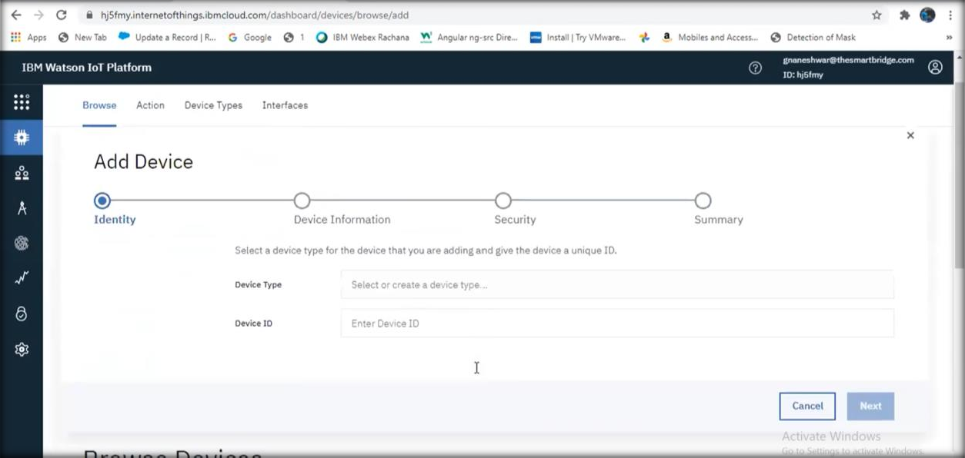

Step 6: Thus the IOT device is created. Copy the device credentials into

a notepad.

